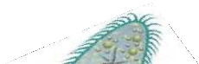
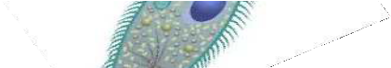
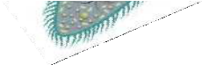

Name: Date:

Protists Graphic Organizer
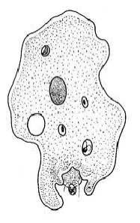
Protist -

Name | Movement | Food
Amoeba
Euglena
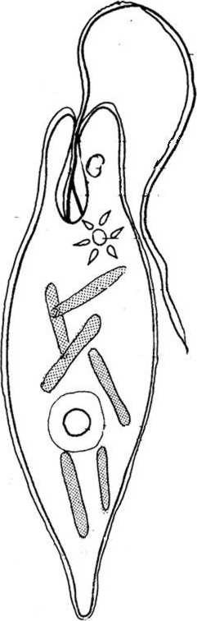
Paramecium
Volvox
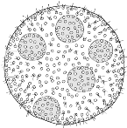

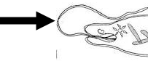
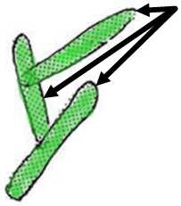
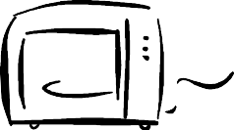
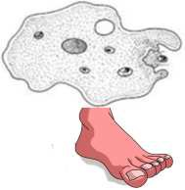
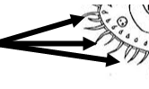
Important Protist Vocabulary

Vocabulary Word | Definition | Picture | Protist
Protist |  | 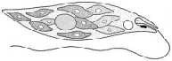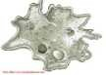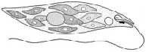 | Amoeba  Euglena  Paramecium  Volvox
Flagellum |  |  | Amoeba  Euglena
(Flagella) |  |  | Paramecium  Volvox
Eye Spot |  |  | Amoeba  Euglena  Paramecium  Volvox
Chlorophyll |  | 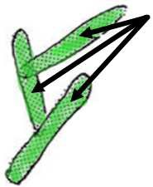 | Amoeba  Euglena  Paramecium  Volvox
Chloroplast |  |  | Amoeba  Euglena  Paramecium  Volvox
Photosynthesis |  |  | Amoeba  Euglena  Paramecium  Volvox
Pseudopod |  |  | Amoeba  Euglena  Paramecium  Volvox
Cilia |  |  | Amoeba  Euglena  Paramecium  Volvox
 |  | 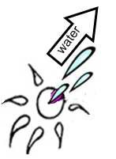 | Amoeba
Contractile Vacuole |  |  | Euglena  Paramecium  Volvox

Food Vacuole |  |  | Amoeba  Euglena  Paramecium  Volvox
Autotroph |  |  | Amoeba  Euglena  Paramecium  Volvox
Heterotroph |  |  | Amoeba  Euglena  Paramecium  Volvox
Compliments of the Alamance-Burlington School System

