Virtual Sheep Heart Dissection!
Objective: In this simulated dissection you will identify parts of the heart that we have studied. Label each view of the heart as you walk through the website. Focus on: Atriums, Ventricles, Chambers, Arteries; color how blood flows through the heart – RED=oxygenated BLUE=deoxygenated
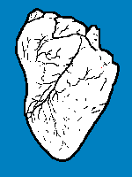
ANTERIOR VIEW

INTERIOR (ANTERIOR) VIEW
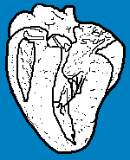
SUPERIOR VIEW
